

Mirror Monitor Safety System

Installation & Operation

Model No : XVRM-R96

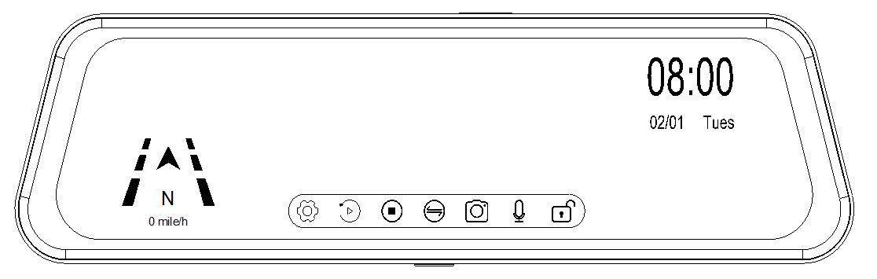

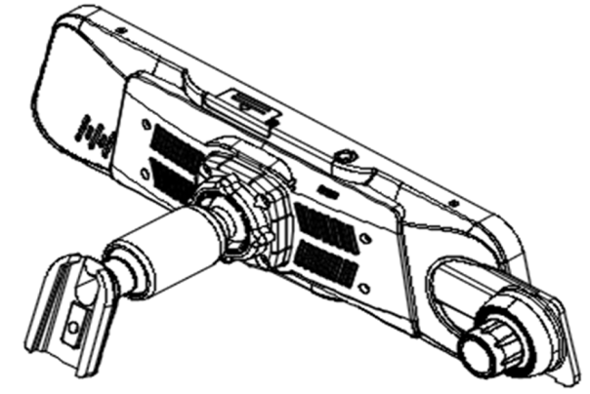

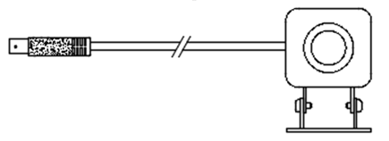

9.66” Digital LCD Mirror Monitor

|  |  |
| --- | --- |
| [https://image.freepik.com/free-icon/triangle-warning_318-28807.png](http://www.google.co.kr/url?sa=i&rct=j&q=&esrc=s&source=images&cd=&cad=rja&uact=8&ved=0ahUKEwjKjuL2s43OAhXMppQKHdcrAuoQjRwIBw&url=http://www.freepik.com/free-photos-vectors/exclamation-mark&bvm=bv.127984354,d.dGo&psig=AFQjCNEQKSzOfLNNh9olHCr-nUH61Rruyg&ust=1469494528868171) | Important – Please Read This Manual Before Installing. |
| [https://image.freepik.com/free-icon/triangle-warning_318-28807.png](http://www.google.co.kr/url?sa=i&rct=j&q=&esrc=s&source=images&cd=&cad=rja&uact=8&ved=0ahUKEwjKjuL2s43OAhXMppQKHdcrAuoQjRwIBw&url=http://www.freepik.com/free-photos-vectors/exclamation-mark&bvm=bv.127984354,d.dGo&psig=AFQjCNEQKSzOfLNNh9olHCr-nUH61Rruyg&ust=1469494528868171) | Objects Viewed In Monitor Are Closer Than They Appear. |

The XVRM-R96 is Not Intended To Replace Any of Your Vehicles Mirrors or Other Safety Devices.

It is Not a Substitute For Proper Defensive Driving Techniques.

Please Obey All Traffic Laws And Motor Vehicles Safety Regulations.

Do Not Open Monitor or Camera Housing.

There Are No Parts That Can Be Serviced.

Opening Monitor Or Camera Housings Will Void Your Warranty.

Red Power Wire Must Be Connected To Accessory That is Turned Off When Key is Removed From Vehicle To Prevent Power Draw.

Table of contents

Chapter 1. Product introduction

1.1 Package

1.2 Features

1.3 Specification

1.4 Dimension

Chapter 2. Installation and wire

2.1 How to install rearview mirror monitor

2.2 How to wire

Chapter 3. Function and Interface

3.1 Rearview mirror monitor function

3.2 Detailed setting menu

Chapter 4. Operation

4.1 Setting

4.2 Playback

4.3 Channel Change

4.4 Audio

4.5 Event Lock

Chapter 5. General Use

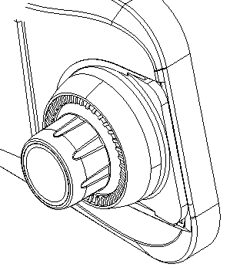

1. Product Introduction
   1. Package

* The packing box contains the following accessories

|  |  |  |  |
| --- | --- | --- | --- |
| Item | Picture | Quantity | Remark |
| Mirror Monitor |  |  |  |
| Rearview Camera |  |  |  |
| Wire Harness |  |  | Power Harness & Camera Extension Cable |
| User Manual |  |  |  |
| Install Bracket  (optional) |  |  |  |
| GPS (optional) |  |  |  |
| For the items listed above, please check with your package box. If any damage, please contact with the distributor or the agent as soon as possible. | | | |

* 1. Features

-. Built-in ultra-high brightness 9.66-inches touch LCD panel

-. Front camera 1080p, Rear camera 720p resolution

-. Maximum 256GB TF card support

-. Input power : max. 32V

-. Parking monitoring

-. Automatic loop recording

-. Synchronized video/audio recording

-. Google-map support on a PC program with GPS

* 1. Specification

|  |  |
| --- | --- |
| Model | XVRM-R96 |
| Display | 9.66 inches touch LCD panel |
| Front Camera | Resolution : 1080p |
| Rear Camera | Resolution : 720p |
| Recording Video Format | MOV |
| Recording Still Image Format | MJPEG |
| G-Sensor | Built-in |
| MIC | Built-in |
| Speaker | Built-in |
| Super Capacitor | Built-in |
| GPS | optional |
| Power Input | DC 12V (max. 32V support) |
| Dimension | 257.7 x 72.0 x 41.4 (mm) / 10.15 x 2.83 x 1.63 (inch) |
| Weight | 368g/unit, 1.4Kg (Full Package) |
| Operating Temperature | -10°C ~ 60°C / 14℉ ~ 140℉ |

* 1. Dimension
* Without mounting bracket

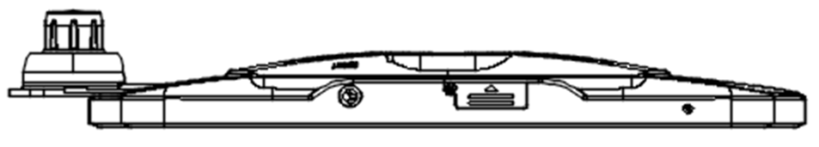

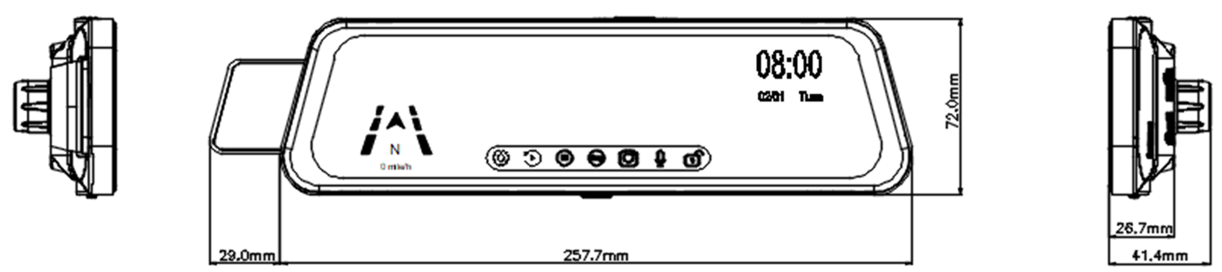

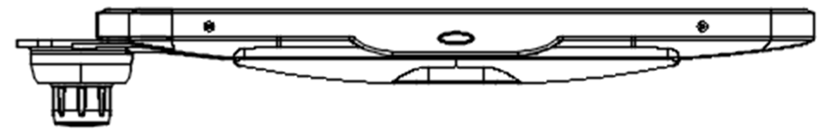

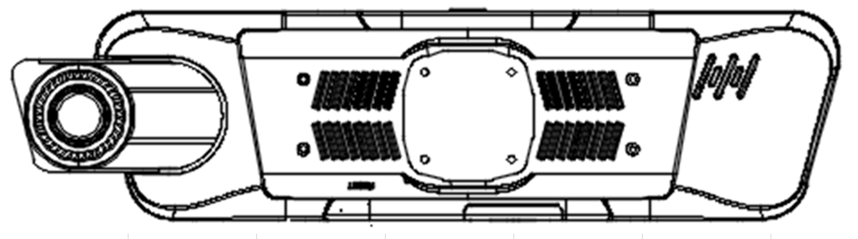

* With Mounting Bracket

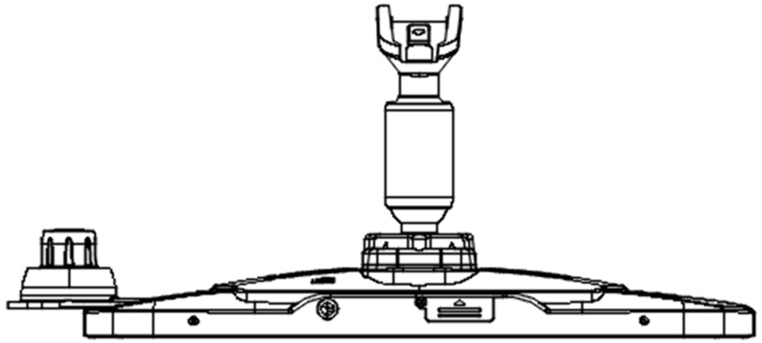

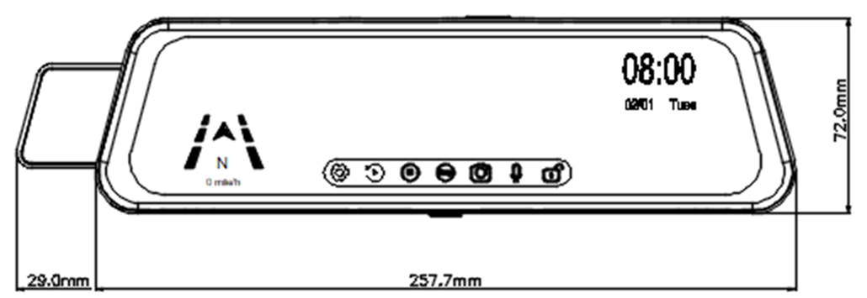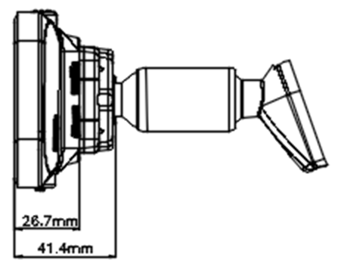

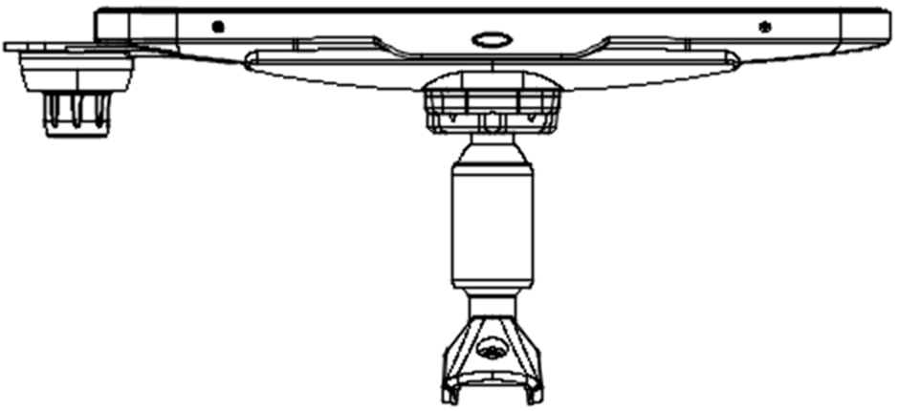

1. Installation and Wire

[](http://www.google.co.kr/url?sa=i&rct=j&q=&esrc=s&source=images&cd=&cad=rja&uact=8&ved=0ahUKEwjKjuL2s43OAhXMppQKHdcrAuoQjRwIBw&url=http://www.freepik.com/free-photos-vectors/exclamation-mark&bvm=bv.127984354,d.dGo&psig=AFQjCNEQKSzOfLNNh9olHCr-nUH61Rruyg&ust=1469494528868171) Power(B+), Ground(-) and ACC shall be connected to each terminal.

This can lead to battery discharge and may interfere with parking mode operation.

[](http://www.google.co.kr/url?sa=i&rct=j&q=&esrc=s&source=images&cd=&cad=rja&uact=8&ved=0ahUKEwjKjuL2s43OAhXMppQKHdcrAuoQjRwIBw&url=http://www.freepik.com/free-photos-vectors/exclamation-mark&bvm=bv.127984354,d.dGo&psig=AFQjCNEQKSzOfLNNh9olHCr-nUH61Rruyg&ust=1469494528868171) STM-R96 checks battery voltage via B+ and ACC.

Monitor power will off from 11V for 12V battery and from 23V for 24V battery.

2-1. How to install rearview mirror monitor

1. Remove the original mirror

-. Different cars have different brackets. It depends on your vehicle maker and manufacturer.

-. There are many methods to remove the original rearview mirror, however please

don’t force the mirror off the bracket.

-. The manufacturer will not be responsible for damage caused to your car by

wrong installation of the mirror.

1. Attach the installation bracket

-. Attach the installation bracket for your vehicle to the rear of the mirror monitor.

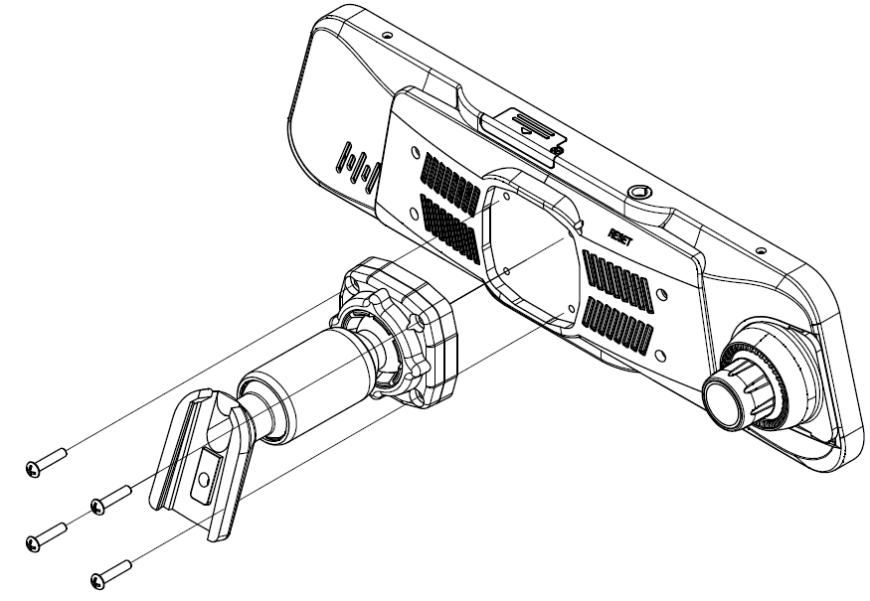

2-2. How to install rearview mirror monitor

* Wiring Diagram

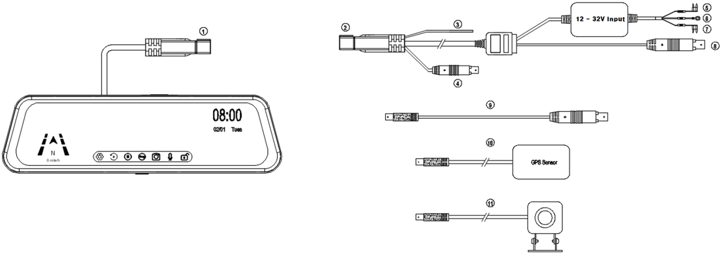

|  |  |  |
| --- | --- | --- |
| No. | Item | Remark |
| ① |  |  |
| - Monitor Connection Cable : Connect ② Power Harness to ① |  |
| ② ~  ⑧ |  | To turn on the monitor ⑤ and ⑦ must be connected |
| ② Power harness |  |
| ③ Trigger cable : Connect to fuse-box for reverse gear |  |
| ④ GPS connector : Connect ⑩ GPS sensor for position and speed |  |
| ⑤ Power connection terminal : Connect to power source |  |
| ⑥ Ground connector : Connect to chassis ground |  |
| ⑦ ACC connector : Connect to ACC power |  |
| ⑧ Rear camera connector : Connect to ⑨ rear camera | To male |
| ⑨ |  |  |
| - Rear camera extension cable |  |
| ⑩ |  |  |
| - GPS sensor : Connect to ④ GPS connector |  |
| ⑪ |  |  |
| - Rear camera : Connect to ⑨ Rear camera extension cable | To female |

1. Function and Interface

3.1 Monitor Front Function & Interface

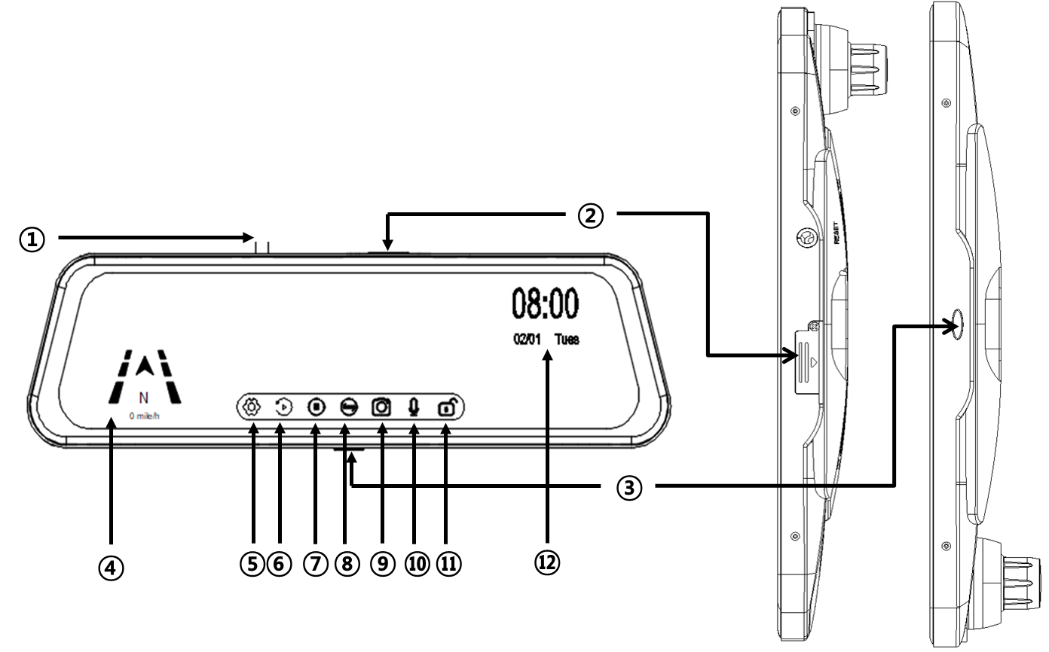

|  |  |  |  |  |  |
| --- | --- | --- | --- | --- | --- |
| No. | Item | No. | Item | No. | Item |
| 1 | Monitor Cable | 5 | Setting | 9 | Screen Shot |
| 2 | MicroSD Card Slot | 6 | Playback | 10 | Audio Record |
| 3 | Power Button | 7 | Record | 11 | Event Record |
| 4 | Direction & Speed | 8 | Display Mode | 12 | Date and Time |

3.2 Monitor Rear Function & Interface

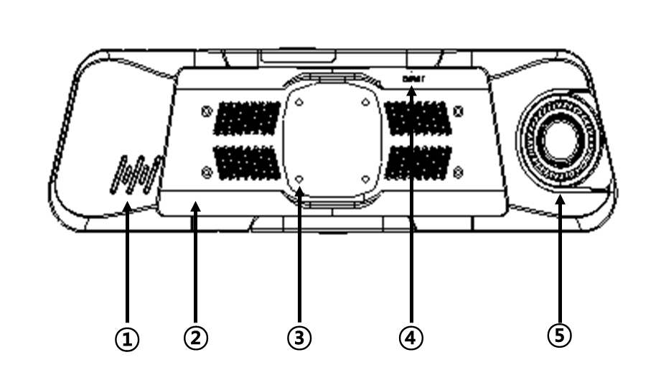

|  |  |  |  |  |  |
| --- | --- | --- | --- | --- | --- |
| No. | Item | No. | Item | No. | Item |
| 1 | Speaker | 3 | Bracket Connection Hole | 5 | Front Camera |
| 2 | Bracket Cover | 4 | Reset Button |  |  |

1. Operation

* How to enter the setting menu

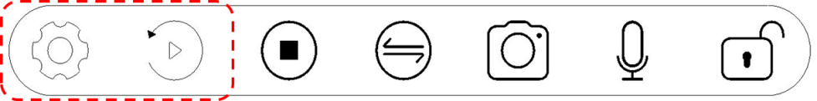

Setting icon and Playback icon is deactivated. Stop record first.

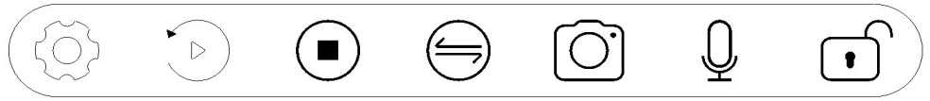

Touch ‘Stop’ icon then Setting icon and playback icon will activate.

, ,

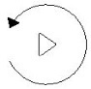

System bar shows as below picture.

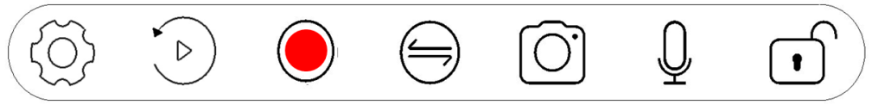

* 1. Setting 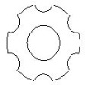

1. Recording Resolution

: Set display -> record resolution 1080p/720p 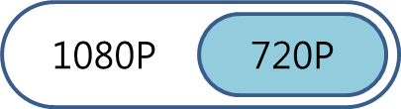

1. Recording Time

: Set recording time every 1,2 or 3 minutes. 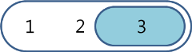m

1. Audio Record

: Set record sound OFF , ON 

1. Dual Cameras Recording

On : Record Front and Rear

Off : Record Front only OFF , ON 

1. Power Off

: Set the power off after certain times when non recording mode. 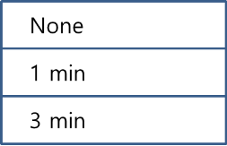

If the monitor is in use, will turn off after the set time after use.

1. Clock Setting

: Set date and time 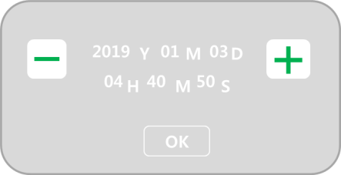

1. Stamp

: Choose whether you want to record GPS information to a file you want to save. 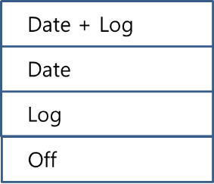

1. Language

: Select the language what you want to use. 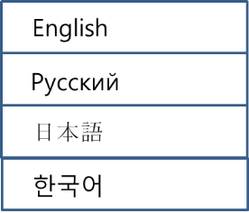

1. Flicker

: Select flicker frequency when the video is flickering. Hz

1. LCD Power Save

: Turn off back light power after certain time 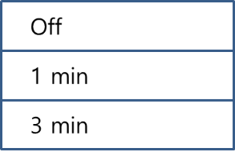

1. On-Screen Mode

: Set the monitor brightness 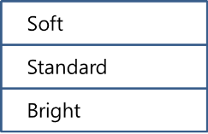

1. Event Record

: Event recording through G sensor while in driving. 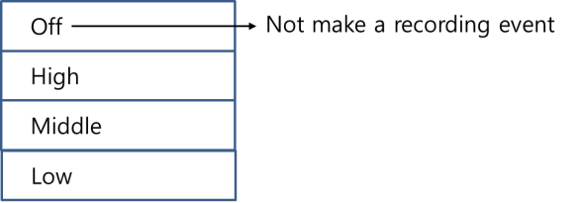

1. Parking Monitoring

: Event recording through G sensor while the vehicle is parked.



When motion or any event happens while the monitor is on a recording, the recording icon will change red circle to yellow circle with blinking.

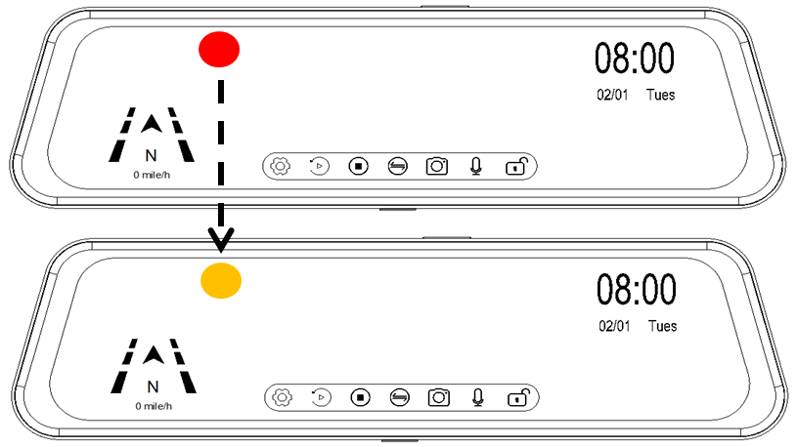

* G-Sensor Level

|  |  |
| --- | --- |
| Off | - |
| High | 1.25G |
| Middle | 1.5G |
| Low | 2.0G |

1. Motion Detection

: Set the motion record or not. OFF , ON 

1. Volume

: Set the monitor speaker volume. 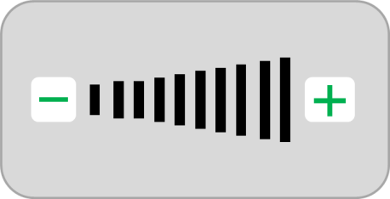

1. GPS Status

: Non setting menu, for the user information. 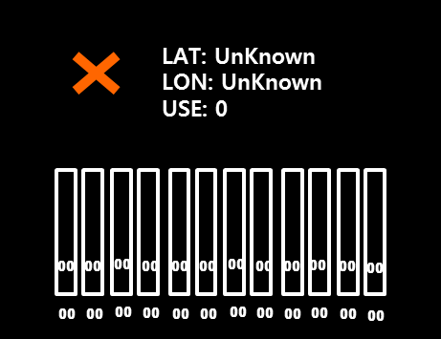

1. Speed Unit

: Select speed unit 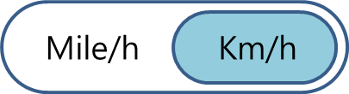

1. Reset Setup

: Make a factory default 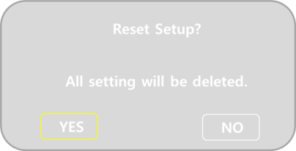

1. Format SD-Card

: Format micro-SD card 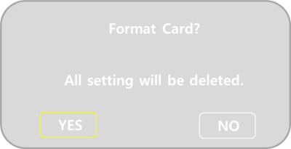

1. Firmware Version

: Show firmware version ‘20190420_V0.1’

1. Back Light Compensation

: Control the back light brightness through finger touch. Getting dark when slide left side and bright when slide right side. 

Control bar come up when the finger slide at the top of the screen.

* 1. Playback 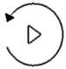

1. Stop recording first to enter the playback menu.
2. If you touch the icon, below screen shows.

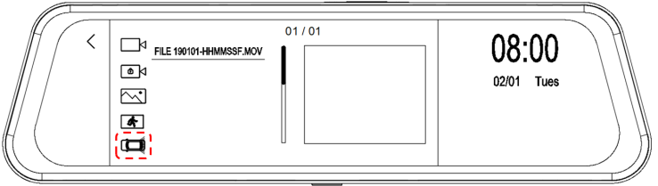

1. Select the camera which camera video want to play.

3-1) Touch  icon then front camera videos will be listed on the right side.

File name will be ‘Filexxxxxx-xxxxxxF.MOV’ last of ‘F’ is ‘Front’ initial.

3-2) Touch  icon then rear camera video will be listed on the right side.

File name will be ‘Filexxxxxx-xxxxxxR.MOV’ last of ‘R’ is ‘Rear’ initial.



※ Recorded File name

|  |  |  |
| --- | --- | --- |
| Recording Mode | Direction | File name |
| Continuous Record | Front | FILEYYMMDD_HHMMSSF.MOV |
| Rear | FILEYYMMDD_HHMMSSR.MOV |
| Event Record | Front | EMERYYMMDD_HHMMSSF.MOV |
| Rear | EMERYYMMDD_HHMMSSR.MOV |
| Parking Motion Record | Front | PARKYYMMDD_HHMMSSF.MOV |
| Rear | PARKYYMMDD_HHMMSSR.MOV |
| Screen Shot | Front | IMGYYMMDD_HHMMSSF.MOV |
| Rear | IMGYYMMDD_HHMMSSR.MOV |

1. Event Playback

: Search the event while ‘Driving’, ‘Parking’ and ‘Motion’ recorded.

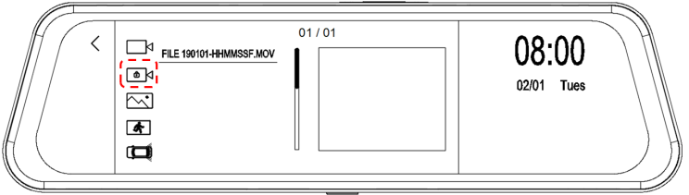

1. Show captured image

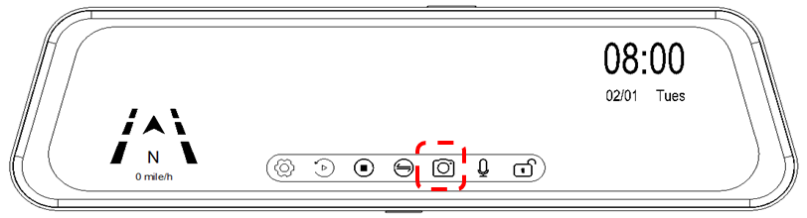

: Files will be listed when the capture through capture icon.

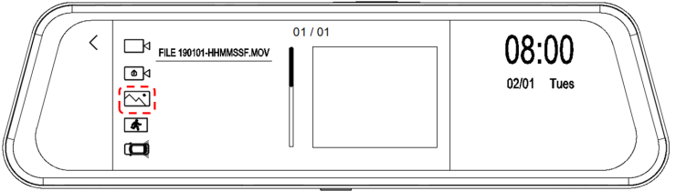

: Touch the red circle icon and files will be listed.

* 1. Channel Change

: Shows rear camera full screen -> Front camera full screen -> Both camera split screen

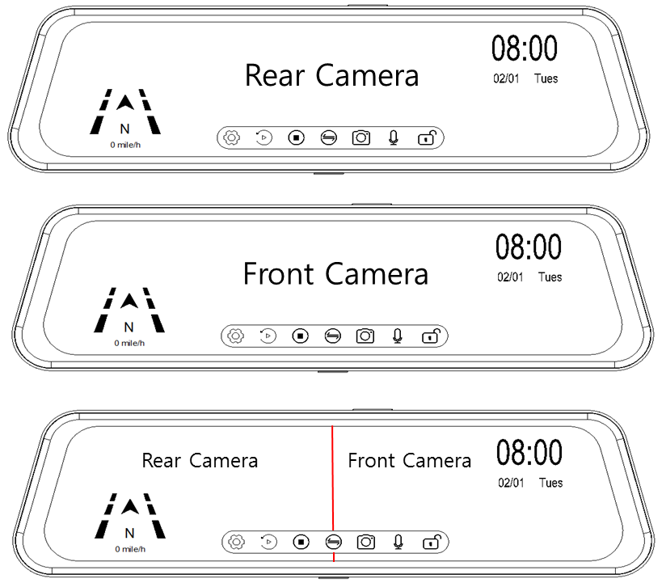

* 1. Audio

: Record audio ‘ON’ , ‘OFF’ 

* 1. Event Lock

When the recorded video files are overwriting, this feature prevent to delete with this lock button.

* Lock Off : All recorded data will be overwriting and stop event recording.
* Lock On  : Manual on for emergency recording start. Event recorded data will not be overwrite.

1. General Use

CLEANING AND GENERAL MAINTENANCE

* Cool off the inside of vehicle when the inside of vehicle temperature is high from the long term direct sun light.
* Clean the unit with a slightly damp soft cloth. Use a mild household detergent.
* Never use strong solvents such as thinner or benzine as they might damage to the unit.
* Do not attemp to service this system without authorized, it may expose to dangerous voltage or other hazards.
* Refer all servicing to qualified service personnel.

【FCC COMPLIANCE STATEMENT】

* This equipment has been tested and found to comply with limits for a Class A digital device, pursuant to

part 15 of the FCC rules.

* These limits are disigned to provide reasonable protection against hamful interference when the equipment

is operated in a commercial environment.

* This equipment generates, uses, and can rediate radio frequency enerty and, if not installed and used

in accordance with the instruction manual, amy cause harmful interference to radio communications.

* Operation of this equipment in a residential area is likely to cause harmful interference

in which case the user will be required to correct the interference at his own expense.

|  |  |
| --- | --- |
| [https://image.freepik.com/free-icon/triangle-warning_318-28807.png](http://www.google.co.kr/url?sa=i&rct=j&q=&esrc=s&source=images&cd=&cad=rja&uact=8&ved=0ahUKEwjKjuL2s43OAhXMppQKHdcrAuoQjRwIBw&url=http://www.freepik.com/free-photos-vectors/exclamation-mark&bvm=bv.127984354,d.dGo&psig=AFQjCNEQKSzOfLNNh9olHCr-nUH61Rruyg&ust=1469494528868171) | Any changes or modifications in construction of this device which are not expressly approved  by the party responsible for compliance could void the user authority to operate the equipment |